

**PROGRAMMING-2**

**A THOROUGH REPORT ON THE DEVELOPMENT OF THE MCDONALD'S FRANCHISE MANAGEMENT SYSTEM**

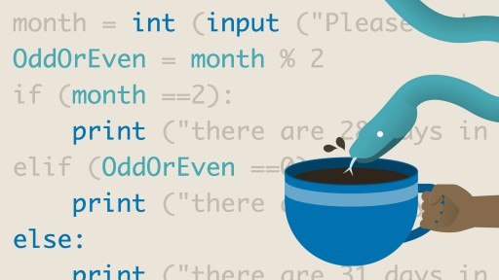

|  |  |
| --- | --- |
| GROUP MEMBERS | M.Ainan Khan, Mir Aqib Hossain |
| EXPERIMENT | Programming project |
| UNDER SUPERVISION | Sir Rizwan Ullah |
| PERIOD | Thursday, 23/05/2024 |

**Mechanical and Sustainability Engineering**

**May-2024**

Table of Contents

PROJECT SYNOPSIS: 2

SYSTEM PREREQUISITES: 2

DETAILED IMPLEMENTATION: 3

IMAGE PROCESSING: 3

DATA STRUCTURES AND CLASSES: 3

INFORMATION PROCESSING AND LOW STOCK WARNING: 4

PROBLEMS AND SOLUTIONS: 4

FUTURE ENHANCEMENTS: 5

CONCLUSION: 5

# PROJECT SYNOPSIS:

This project aims to create a powerful Qt GUI application that facilitates sales processing, inventory management, and forecasting future requirements for a McDonald's franchise. Advanced features like image processing for scanning receipts and machine learning for sales forecasting are included in the system.

# SYSTEM PREREQUISITES:

Python is a programming language.

**PyQt5:** For the GUI application.

**Pandas:** To manage data manipulation tasks.

**NumPy:** A Python package for numerical operations.

**Scikit-learn:** To put machine learning models into practice.

**Matplotlib:** For data plotting and picture presentation.

**Pillow (PIL):** For importing and transforming images.

1. System Elements Qt GUI Application:

The system's central component offers an intuitive user interface for all features.

1. Image processing:

Loads, processes, and analyses receipt images using PIL.

1. Classes and Data Structures:

Data and functionality are encapsulated using object-oriented programming.

1. Processing of Data and notifications:

Keeps track of inventory information and sends out low-stock notifications.

# DETAILED IMPLEMENTATION:

1. Inventory Dashboard for Qt GUI Application:

Shows current stock levels, makes refilling easier, and refreshes inventory in real time.

1. Receipt Scanner:

Utilizes Open CV to automatically update inventory by scanning and interpreting receipt pictures.

1. Sales Prediction:

Based on past data, scikit-learn is used to forecast future sales trends.

# IMAGE PROCESSING:

1. Image Loading and Conversion:

To make processing easier, images are loaded and converted to grayscale.

1. NumPy array conversion:

To make images compatible with OpenCV, images are transformed into NumPy arrays.

1. Thresholding:

To improve the text on receipts for improved OCR recognition, binary thresholding is applied.

1. Displaying photos:

Processed photos are shown within the GUI by using Matplotlib.

# DATA STRUCTURES AND CLASSES:

1. Inventory Item:

Oversees stock levels and provides procedures for replenishing and updating them.

1. Transaction:

Manages sales transactions, documenting specifics such as the products sold, the amount, and the cost.

1. Receipt Processor:

Uses OCR to extract text from photos and adjusts inventory based on information from receipts.

1. Database:

For development purposes, uses pandas Data Frames to simulate database interactions.

# INFORMATION PROCESSING AND LOW STOCK WARNING:

1. Data Loading:

The system loads inventory data from a CSV file.

1. Inventory Checking:

To ascertain whether there is insufficient stock, the system compares each item to its threshold.

1. Alert Generation:

The system sends out alerts to management when stock levels drop below predetermined levels.

# PROBLEMS AND SOLUTIONS:

* Image Recognition Accuracy:

Preprocessing methods such as thresholding and noise reduction can improve OCR accuracy.

* Real-time Data Handling:

Effective data management techniques are necessary to guarantee that the system updates and reflects changes instantly.

* User Interface Design:

Creating an intuitive graphical user interface (GUI) that can handle multiple features at once.

# FUTURE ENHANCEMENTS:

* Integration with Real-Time Sales Data:

Integrating the system with a point of sale (POS) allows for real-time updates.

* Advanced Machine Learning Models:

Using more complex models to improve the accuracy of predictions.

* Cloud Database Integration:

Using a cloud-based database instead of pandas Data Frames to provide remote management and scalability.

# CONCLUSION:

Using cutting-edge software development techniques and processes, the McDonald's Franchise Management System provides a thorough solution for inventory and sales management. By using automation and predictive analytics, it improve operational efficiency and greatly facilitates decision-making. This paper provides a concise picture of the project from conception to realization by encapsulating the scope, implementation details, and possible impact of the McDonald's Franchise Management System.